TLDR:
Summary | Recommendation
- We expect overall employee churn (net loss) & turnover (total loss) to be 15% & 26% respectively for FY 2025  - Largest drivers for turnover is employee tenure & working from either the Seattle or SanFran branches | - Investigating the differences between Seattle/SanFran & the NYC location, as both have similar work forces but different churn rates  - Paying extra attention to associates with < 2 years of tenure & identify what is driving turnover

Hypothesis
Pay rate, job function, location, tenure & total promotions are correlated with turnover.

Data
Assumptions | Description
- Total promotions only include what can be observed in the data (associate may have received a promotion prior to 2022)  - We assume any job changes in data imply a promotion | - Given data (Geographical/Job Characteristic)  - Total tenure role tenure for associates  - Total promotions (unique job function/level combinations

Methods
Analytical – Time Series | Machine Learning
- We visually inspect the data & apply a standard time series model. Put simply, this is an elevated moving average | - We utilize all of our employee data & apply an ML model to predict if our active associates are likely to leave the company

Results
- For FY 2025 our time series model predicts 15% churn & our ML model predicts 26% turnover
- Churn/Attrition rates show similar results with both models (within 5%) except for Sales & StrategyOps
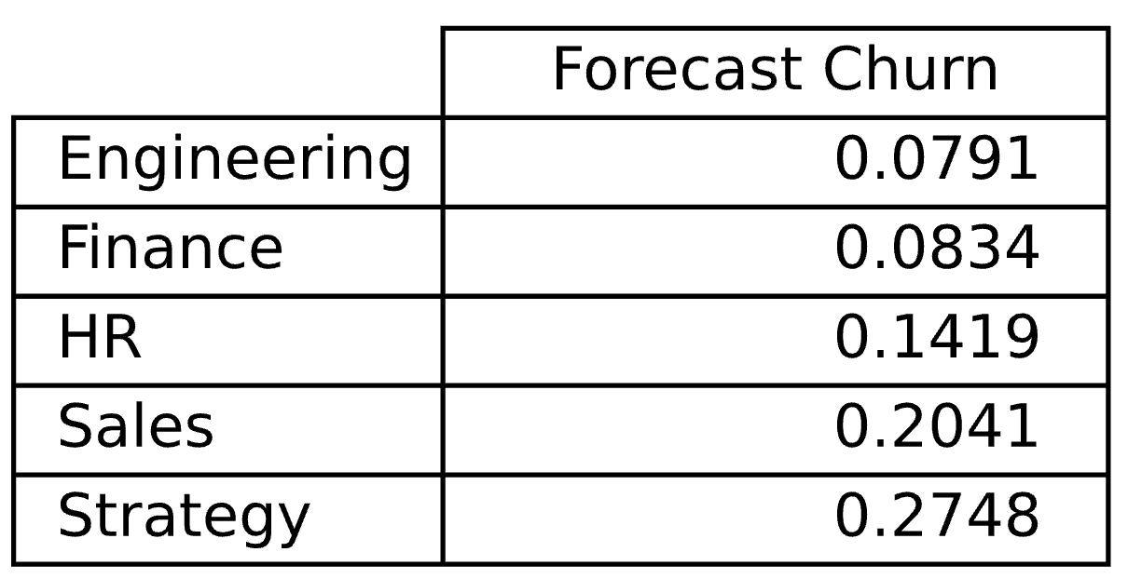 | 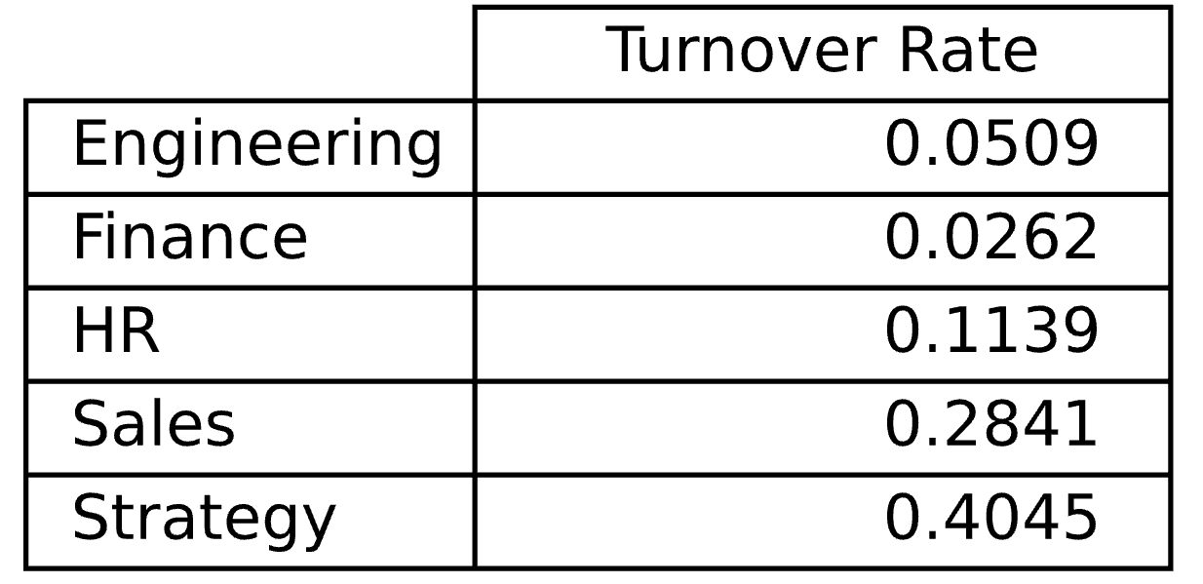
Weighted average 15% | Weighted average 26%

Recommendation
- Since Churn only captures net staff levels not how many associates have left the company, we would be better to estimate turnover & set a hiring rate to achieve the desired churn rate

Appendix

Supplemental Notes
Data Cleaning
- We assume an employee’s hire date is the earliest date between recorded hire date & effective date
  - 26% of the data contained a hire date after a recorded effective date
Trends Churn
- Hourly Staff have highest rates of churn
  - Hourly staff is also highly collinear with OpsStrategy & the MoonMar1 location
- OpsStrategy has the highest rate of churn & is a near constant pattern since 2023 around 27% per quarter
- Sales has the next highest rate of churn, is highly seasonal, averaging 22% per quarter
- HR had a constant churn rate in early 2022, high variability in 2023, then stabilizing in 2024
  - was churn due to voluntary resignations, layoffs, or a combination? This will help determine the best forecast for 2025
- Both engineering & finance have the lowest churn rates and follow a nearly identical seasonality
  - Engineering is highest job type correlated with positive tenure (21%) followed by finance (7%), likely driving lower turnover rates
Churn Visuals
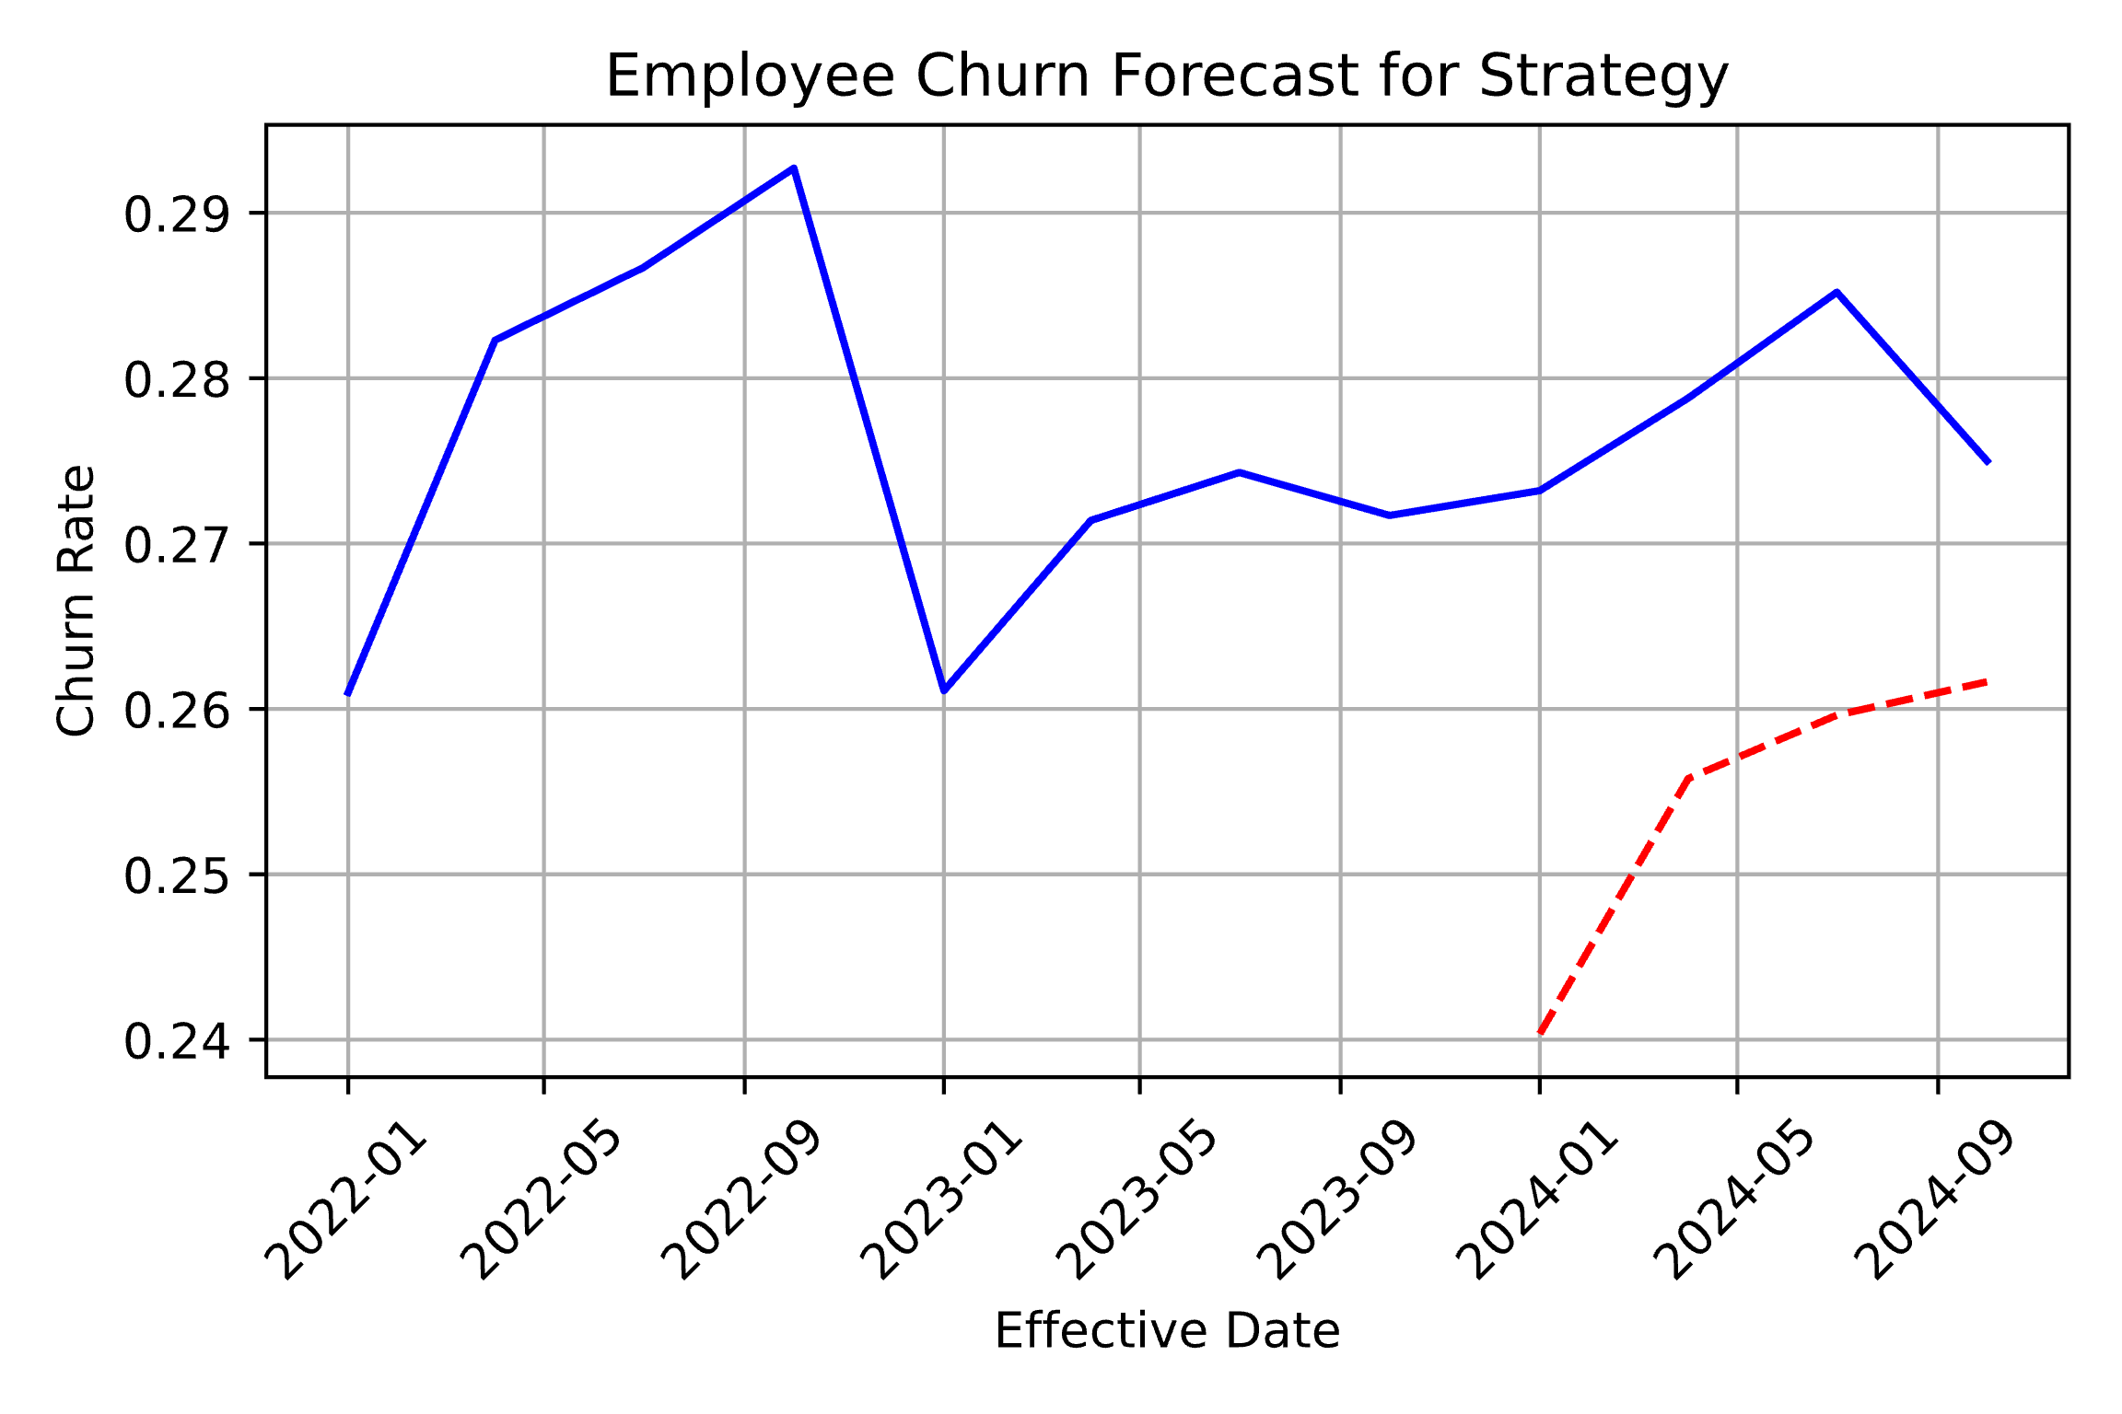 | 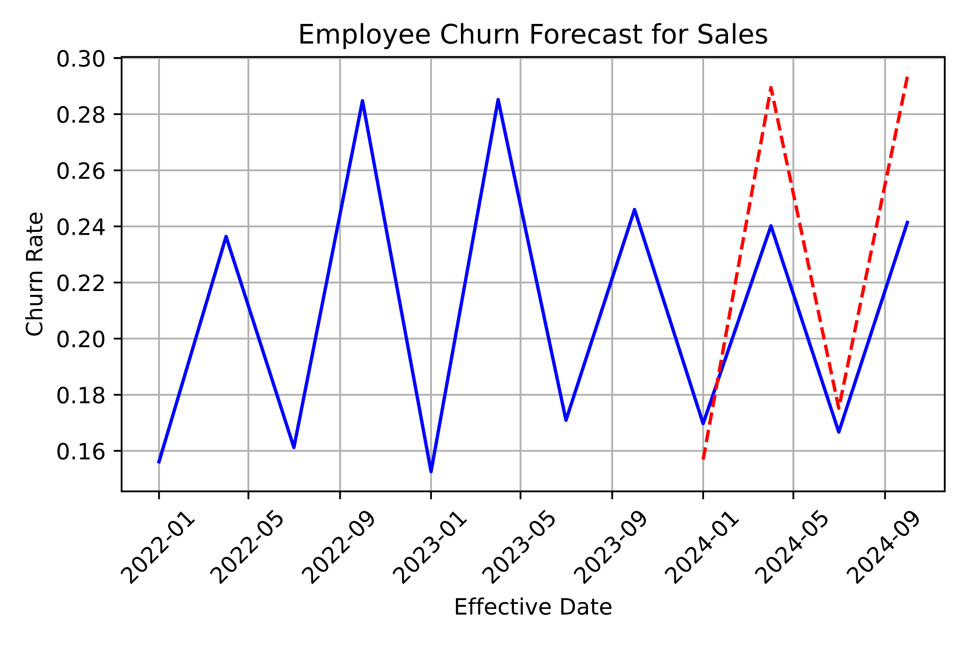
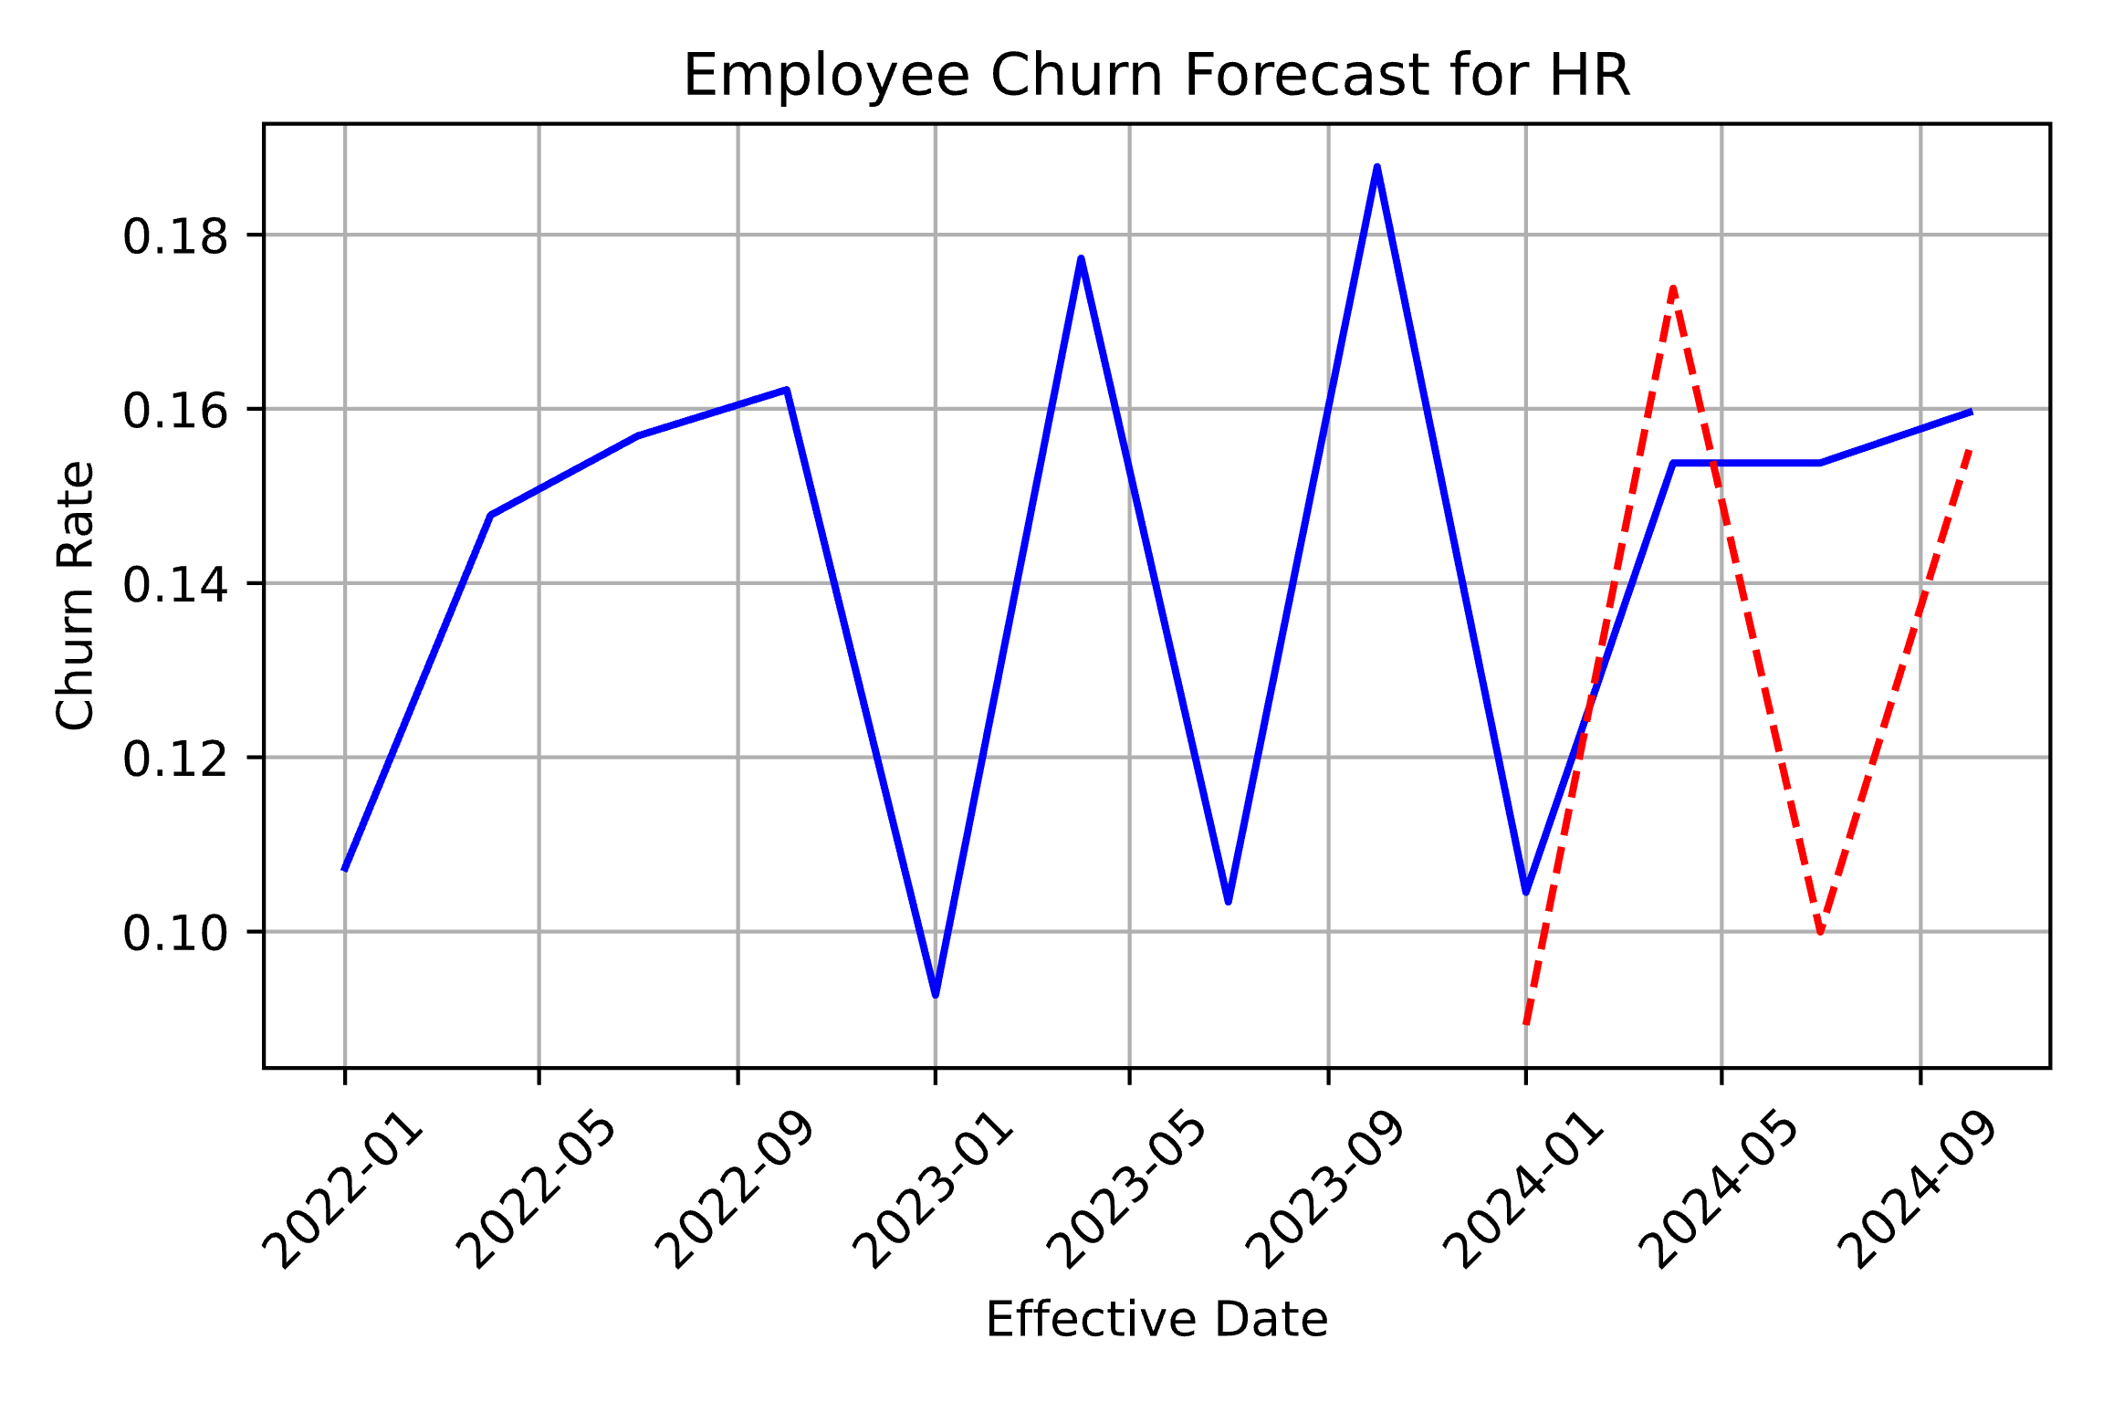 | 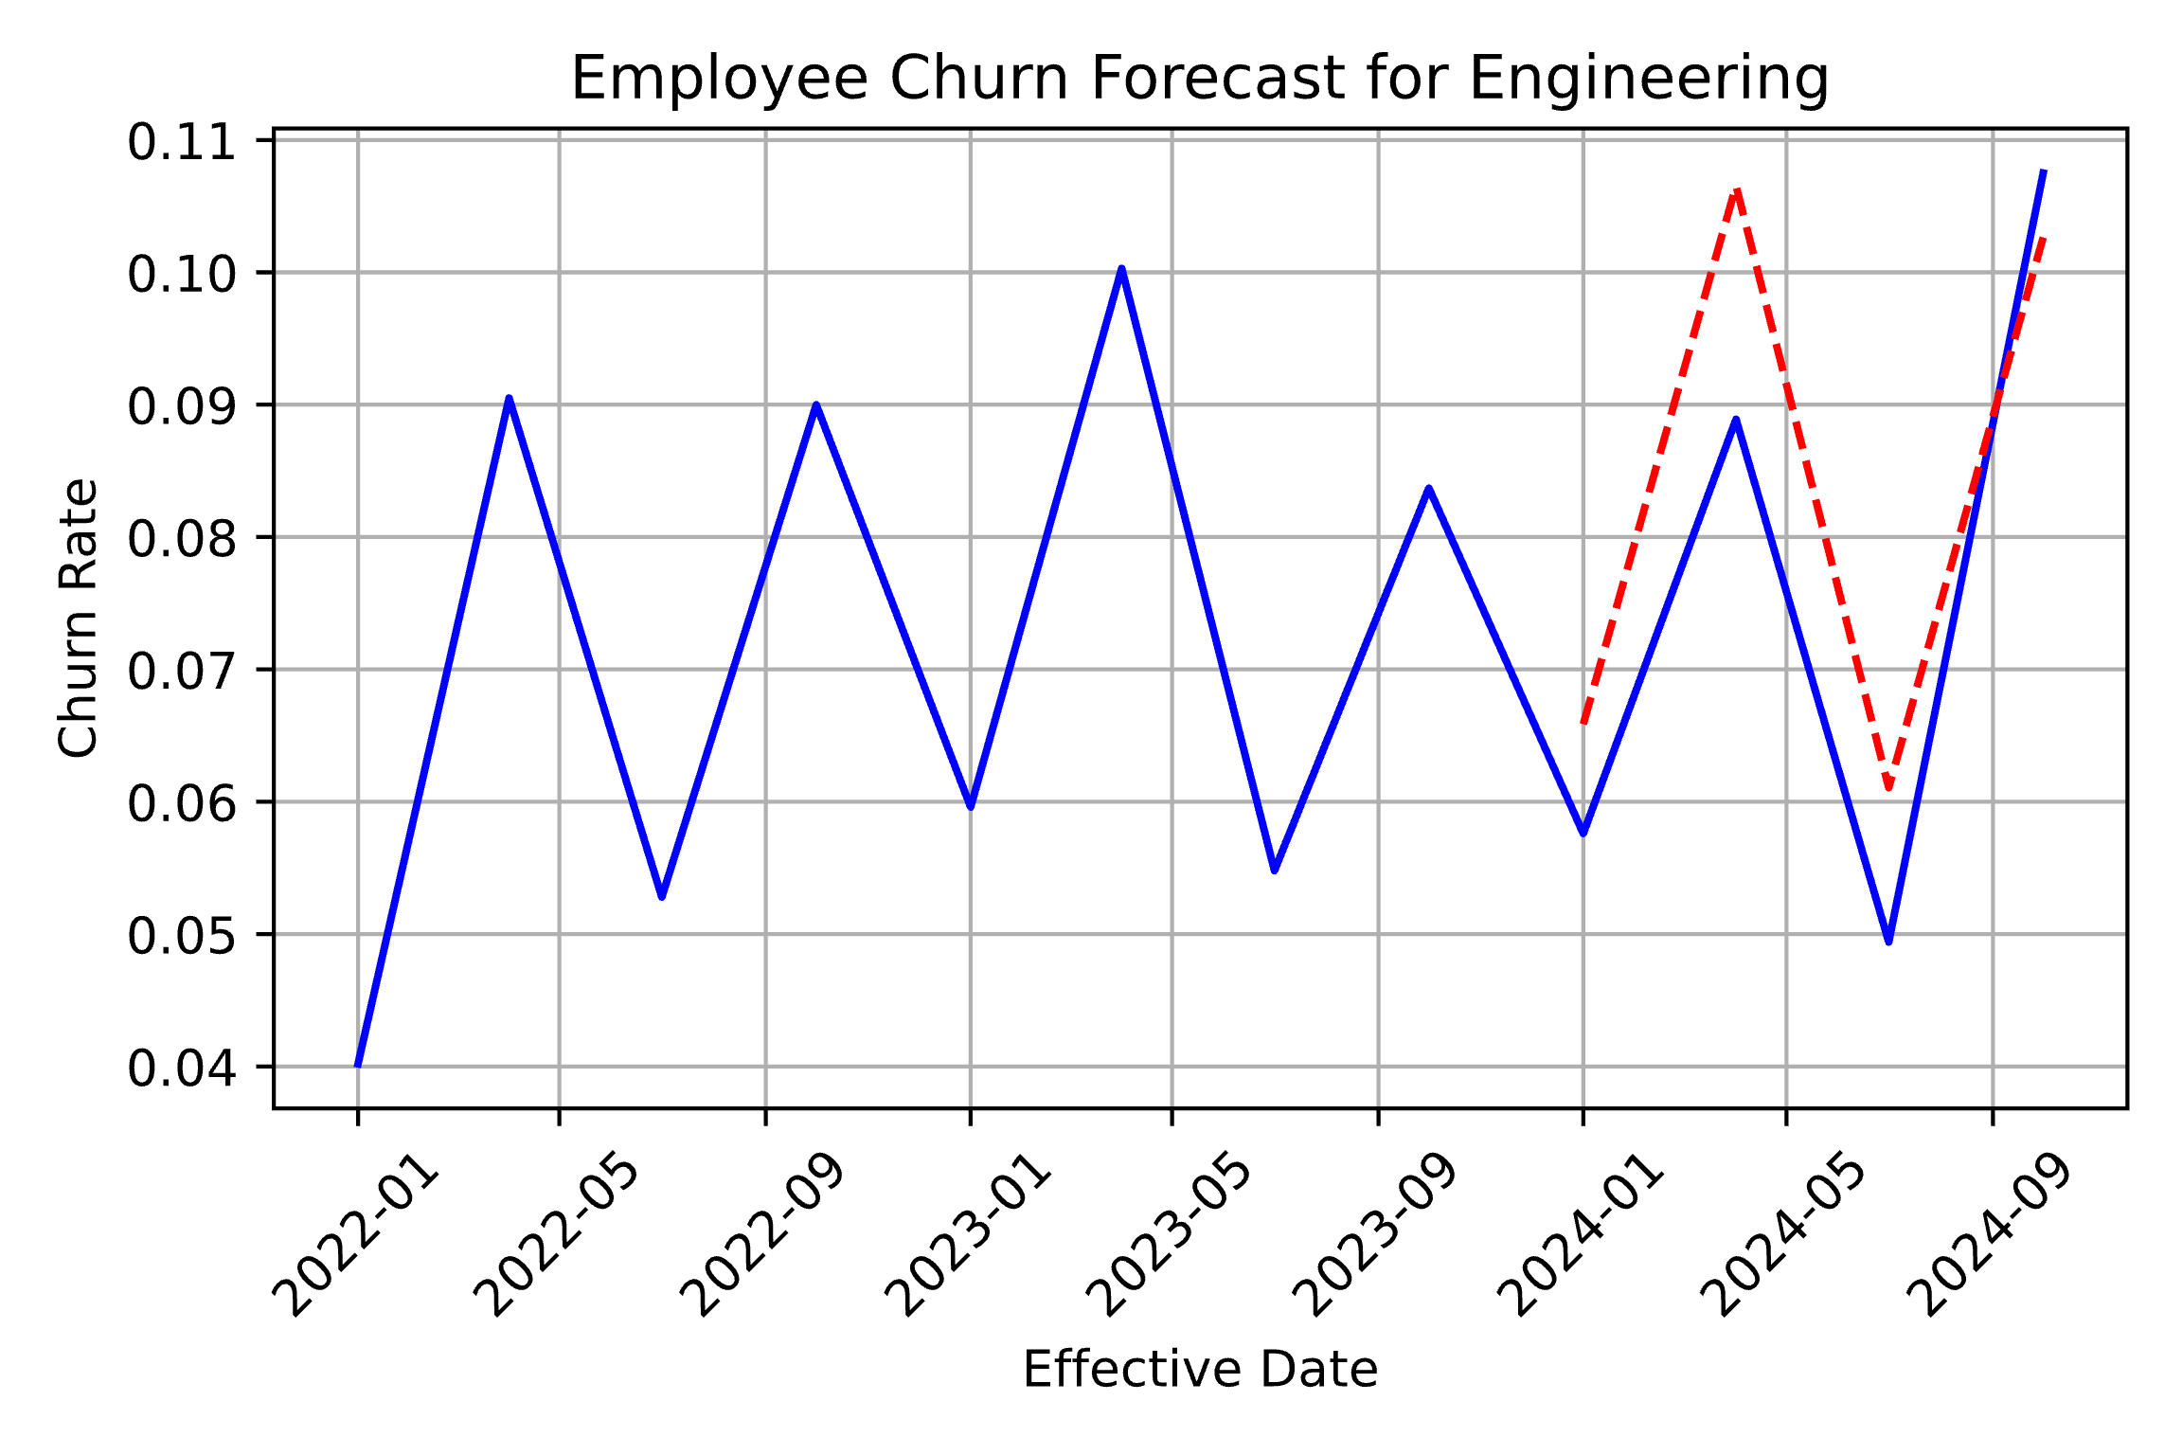

Churn Drivers
- From our ML model we find that Tenure is the most important factor in determining if an associate will leave the company
  - We find a steep drop-off in turnover for tenure < 2 years
- A secondary finding Seattle & San Francisco associated with lower turnover rates than NYC although all three locations have similar distribution of job role types
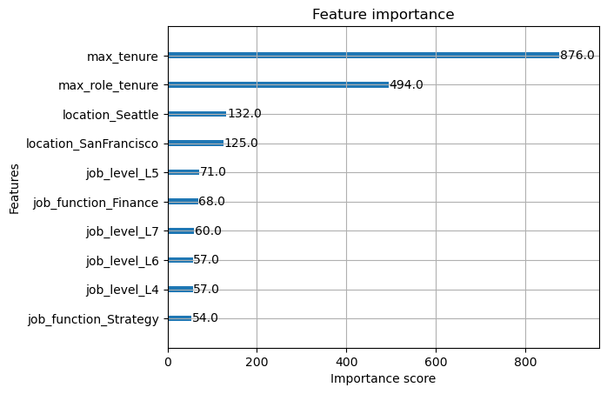 | 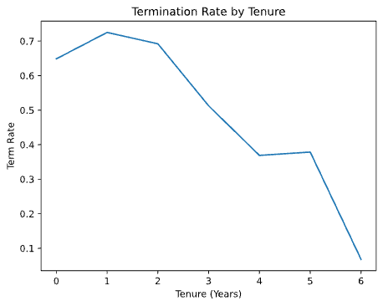

Models - Exponential Smoothing
- We use an exponential smoothing model with additive seasonality & trend, this model fits well for Engineering & Sales, but has large misses in the other job types
- If we proceed with this method, it is recommended to:
  - Switch OpsStrategy to a moving average since it is fairly stable quarter over quarter since 2023
  - Investigate why the model overshot for Finance but not Engineering. As both jobs have fairly similar patterns it may be worth combining them
- To measure accuracy, we use first 8 periods in the data to build the model & test on the remaining 4 periods
- We calculate a weighted MAPE of 12.71%, weighting by a job function (to account for differences in workforce sizes)
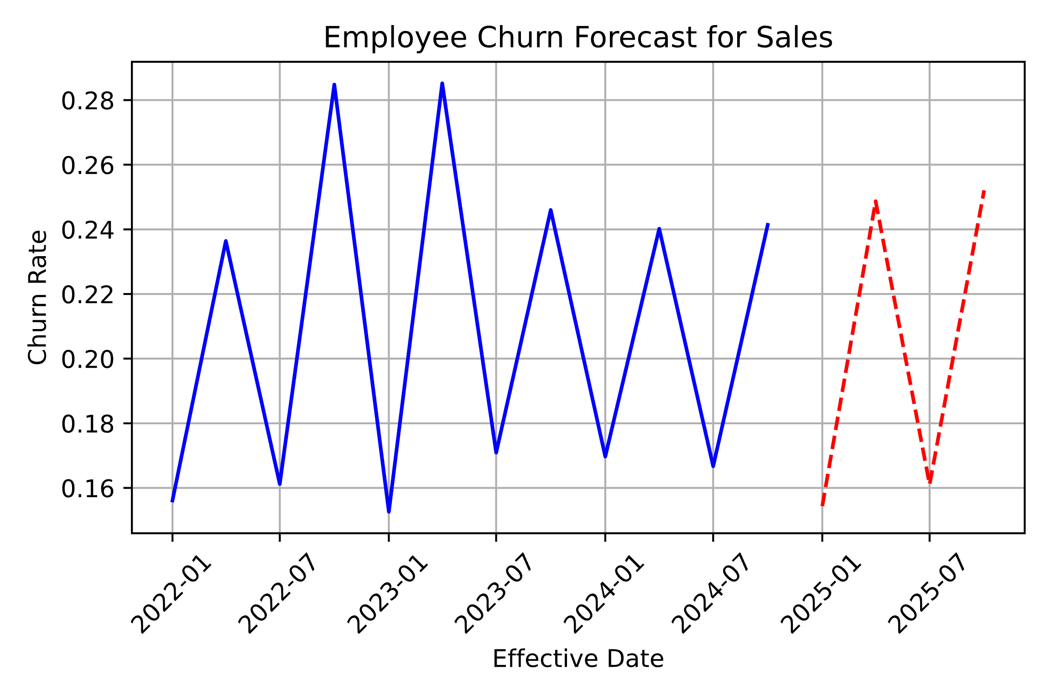
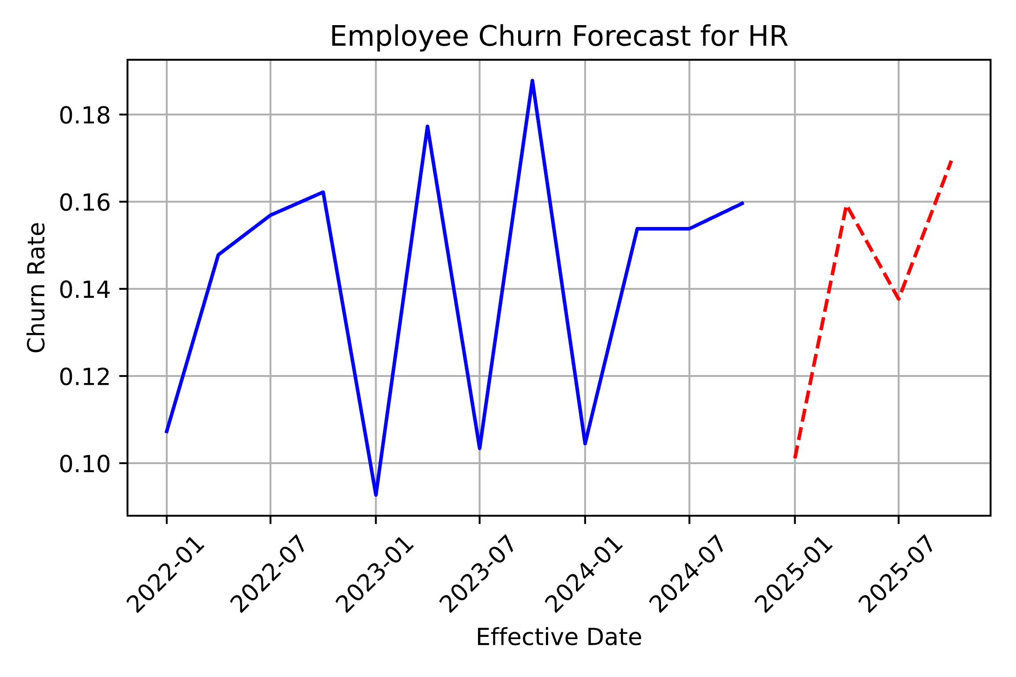 | 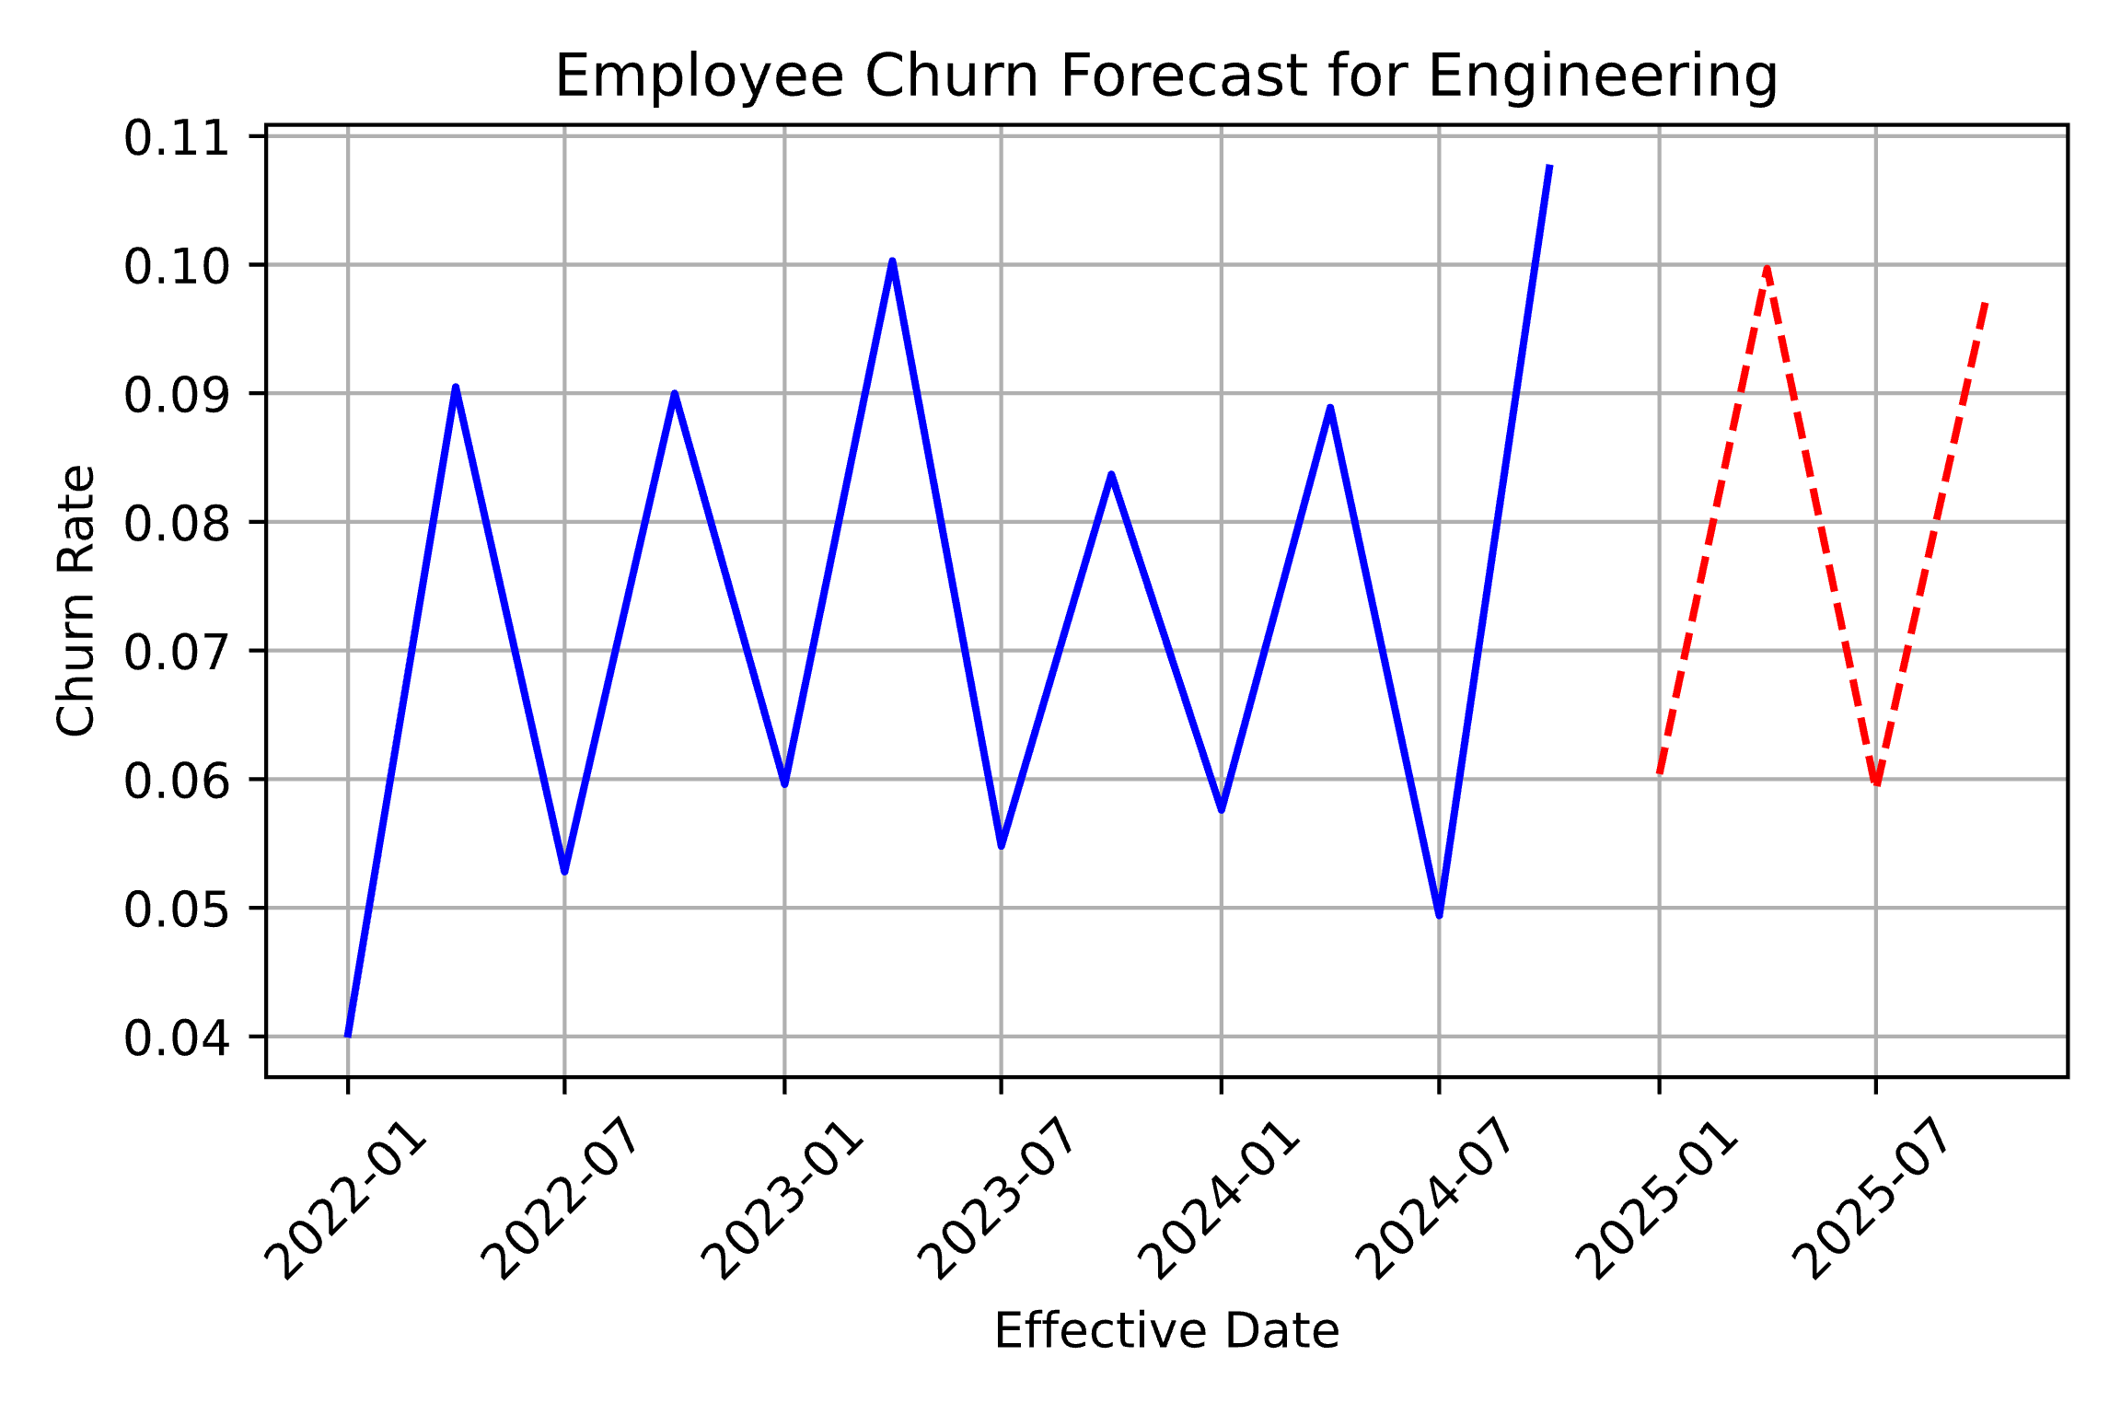
Models - ML
- We use XGBOOST Classifier (logistic random forest) to predict if a given associate is likely to leave the company
  - To estimate churn, we must back it out from predicted employee turnover
  - As we are predicting at an associate level how likely the are to leave, we do not have a quarterly forecast, but an entire workforce prediction
    - We can apply our turnover rate and scale historical quarters should we need a quarter-by-quarter estimation
Model Specifics
- We apply a proportional sampling of terminated/active associates as well as job type
  - This prevents the model overfitting to a specific job type
- 70% of data is used for training & the remaining 30% split equally between validation & testing sets
- The model accurate predicts employee turnover with 84% accuracy
Enhancements
- To improve the model having additional factors such as associate age, marital status, & workforce modality could benefit

Code
Data Prep
Data Modeling

